Postwar America ‖ Primary Source Analysis on CMC

Goals & Objectives
Students will demonstrate critical analysis of primary sources on the Cuban Missile Crisis and the respective leaders of the nations involved in order to conclude how the foreign policies and political ideologies of Castro, Kennedy, and Khrushchev impacted the crisis.
Students will demonstrate their knowledge by answering DBQ questions for each primary source document and discuss the various policies and ideologies of the respective leaders in small groups.
Students will synthesize and corroborate the primary source documents in order to determine how the nation’s leaders affected the Cuban Missile Crisis and how the role foreign policies and ideologies played in the event.

California State Content Standards
11.9. Students analyze U.S. foreign policy since World War II.
3. Trace the origins and geopolitical consequences (foreign and domestic) of the Cold War and containment policy, including the following:
• The Bay of Pigs invasion and the Cuban Missile Crisis

Common Core Literacy Standards
CCSS.ELA-Literacy.RH.11. 2. Determine the central ideas or information of a primary or secondary source; provide an accurate summary that makes clear the relationships among the key details and ideas.

CCSS.ELA-Literacy.WHST.11. 9. Draw evidence from informational texts to support analysis, reflection, and research.

Driving Historical Question
How did the foreign policies and political ideologies of Fidel Castro, John F. Kennedy, and Nikita Khrushchev impact the Cuban Missile Crisis? How did these beliefs affect the eventual resolution?
Was the crisis a justified defense or provocative response on the part of the Soviet Union and Cuba?

Lesson Introduction (Anticipatory Set/Hook/Accessing Prior Knowledge) ‖ Time: 8
Students will be provided the following political cartoons by projection on the smartboard and will be asked to analyze them for meaning. Students will complete the Bell Ringer on a lined piece of paper with a pen/pencil. For each image, students will answer the following prompts: 1) “Let’s get a lock for this thing” cartoon shows a beastly hand coming out of a container labeled “Nuclear War.” Infer as much as possible from this caption and political cartoon. 2) “This hurts me more than it hurts you” shows a frustrated Khrushchev pulling out Castro’s Nuclear teeth. What can you infer from this caption and political cartoon? Do you have any questions about either of the two cartoons?
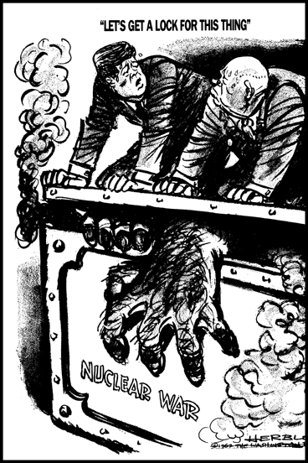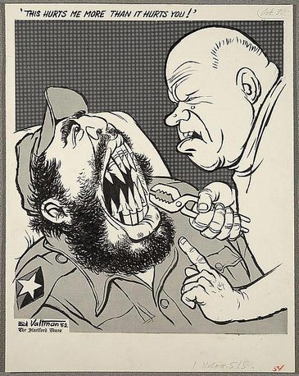

Vocabulary (Content Language Development) ‖ Time: Throughout Lesson
Content Vocab: Fidel Castro
Nikita Khrushchev
John F. Kennedy
Cuban Missile Crisis

Academic Vocab: foreign policy
Political ideology

The vocabulary will be infused throughout the lesson. Students will be encouraged to refer to their textbooks, dictionaries, or phones to look up terms they do not understand. The formulation of answers to the primary source analysis questions will help students understand the academic vocabulary such as foreign policy and political ideology because they will be consistently asked about these aspects of the political leaders.

Content Delivery (Method of Instruction) ‖ Time: 35
Students will be given 5 primary source documents in a DBQ format handout (Docs A, B, C, D, E). Students will be instructed to read and analyze the primary source documents by sourcing, contextualizing, close reading, and corroborating the documents. The driving historical question will be presented at the opening of the lesson and throughout the DBQ by having students repeatedly rewrite the question at the top of each document: How did the foreign policies and political ideologies of Fidel Castro, John F. Kennedy, and Nikita Khrushchev impact the Cuban Missile Crisis?

Students will answer the DBQ questions that facilitate the critical thinking necessary to complete the aforementioned strategies of sourcing, contextualizing, etc. The teacher will demonstrate and model for students on how to close read and annotate the text. Metacognitive markers and highlighting key ideas or phrases will be employed to ensure that students are raising questions, providing insight, and challenging the text. Students will complete the reading independently. After highlighting, annotating, and completing the reading, students will work in flexible groups of 3-4 to answer the primary source analysis questions found in the DBQ following each document.

The teacher will also demonstrate how to source, contextualize, close read, and corroborate the documents. The teacher will demonstrate sourcing by modeling students the questions to ask before reading the document: Who wrote this? Why? How does the historical context fit into the document? When was it produced? These questions and more will help students to place a valued judgement on the credibility of the source itself. For contextualizing, the teacher will model the following questions students should ask when reading the documents: What was the motivating factor in the creation of this document? What background information should I know before I read this document? How did the historical context impact the creation of this source? For close reading, the teacher will model the following questions: Why does the creator of this source hold this opinion? What is fact? What isn’t? What is being said in this source? What is being omitted? For corroboration, the teacher will model the following questions students should ask: What can we conclude after comparing and contrasting these documents? How do we answer the driving historical question? How would others view this source? Is this source believable? Why or why not?

Students should recall factual background knowledge from their previous reading lesson. However, the teacher will provide students with a timeline for reference and to revisit the content at the back of the DBQ questionnaire document. Students who have internet access on their phones, tablets, or other technological devices (at home or in the classroom) will be encouraged to engage with the interactive timeline found on the JFK library website. At the opening of the lesson, the teacher will engage in a class discussion that will help students recall the necessary background information such as: What countries were involved in the Cuban Missile Crisis? How did the policy of containment play into the crisis? What year did the crisis begin to unfold? In what country did the U.S. have nuclear weapons stationed that would make the Soviet Union worried? What happened during the Bay of Pigs? Who led it? What was the historical significance of the Bay of Pigs? How did this influence the U.S.S.R.’s foreign policy towards the U.S. and vice versa?

Student Engagement (Critical Thinking & Student Activities) ‖ Time: 40
The Document Based Questions will provide the students an opportunity to demonstrate their understanding and critical analysis of each of the primary source documents. Students will find that there may be more questions than answers that these documents raise. Also, the questions will guide students in sourcing, contextualizing, close reading, and corroborating each source. The synthesis of the sources will help students to complete the summative assessment which will involve writing a 1-2 paragraph summary in relation to the driving historical question.

Students will be asked to complete the written document analysis worksheet on one written primary source document from the DBQ. This worksheet provides additional support to the teacher modeling and demonstration of how to close read, contextualize, and source a document. Students will complete this activity individually. The teacher will provide a modeling of how to complete this worksheet and how to answer the various questions.

The primary source analysis tool and graphic organizer will provide yet another opportunity for students to engage in critical thinking of the sources they have read. Students will work in purposefully chosen partner groups of no more than 2 to complete the analysis tool activity. For the primary source analysis tool, students will choose one written document to observe, reflect, and question the source. It will also allow students to conceptualize other inquiries related to the Cuban Missile Crisis for further investigation. The teacher will provide a modeling of how to complete this analysis tool and explain what is expected to be written in the observe, reflect, and question portions of the assignment.

The graphic organizer will require students to answer the investigative question or driving historical question with one written document, and the two primary source photographs. The graphic organizer will be completed individually. The organizer asks students to conclude their final thoughts about the investigative or driving historical question: How did the foreign policies and political ideologies of Fidel Castro, John F. Kennedy, and Nikita Khrushchev impact the Cuban Missile Crisis? This will allow students to formulate their answer for the summative assessment which includes a 1-2 paragraph summary that answers the driving historical question. The teacher will provide a modeling of how to complete the graphic organizer and will explain the various questions.

Lesson Closure ‖ Time: 15
After completing all of the assignments above, students will be asked to address the driving historical question using at least 3 of the primary sources they have read and analyzed. Two of the sources must be a written primary source. This will require students to synthesize, evaluate, and corroborate all of the necessary components that make up each document to conclude how each political leader’s policies and ideologies impacted the Cuban Missile Crisis. Who is to blame? Is it a combination of all three leaders, two, or just one? Who is most responsible? What policies or beliefs influenced the events that occurred before, during, and after the Cuban Missile Crisis? These questions will be prompted to students to help expand their understanding and conceptualization of the sources.

Assessments (Formative & Summative)
Formative Assessments: The DBQ questions, primary source analysis tool and graphic organizer will provide the students and teacher formal formative assessments that will demonstrate student learning and understanding of the primary source documents. Students will work individually, in pairs, and in groups to vary their learning experience. The teacher will facilitate discussion and interaction with peers and the documents by prompting students questions throughout the lesson. By progress monitoring student learning, the teacher will be able to informally assess the progress of the student activities. The DBQ, analysis tool, written document analysis worksheet, and graphic organizer will provide students the opportunity to discuss and critically analyze the evidence in order to form a synthesis and corroboration of the documents. Ultimately, this will provide students the necessary knowledge and critical thinking skills to complete the 1-2 paragraph summary that directly responds to the driving historical question.

Summative Assessments: The 1-2 paragraph summary will provide the teacher and students a summative assessment of student learning at the closure of the lesson. Using their activities and DBQ assignment, students will engage in a synthesis and corroboration of 3 documents, two which must be written documents. Students will respond to the questions: How did the foreign policies and political ideologies of Fidel Castro, John F. Kennedy, and Nikita Khrushchev impact the Cuban Missile Crisis? How did these beliefs affect the eventual resolution? Was the crisis a justified defense or provocative response on the part of the Soviet Union and Cuba? Who is to blame? Is it a combination of all three leaders, two, or just one? Who is most responsible? What policies or beliefs influenced the events that occurred before, during, and after the Cuban Missile Crisis? Thus, this assessment will provide students the opportunity to demonstrate their learning and critical thinking skills in relation to the driving historical question, the documents, and the political leaders of Cuba, U.S., and the Soviet Union.

Accommodations for English Learners, Striving Readers and Students with Special Needs
English language learners will be provided a translated text if necessary. The flexible and purposeful grouping by the teacher will allow for students to be paired according to their ability. EL’s will be provided a separate DBQ that is already highlighted and annotated depending on the level of English proficiency. EL’s will be encouraged to speak in their primary language during the group work. If necessary, EL’s will be provided extra time in the class and will be allowed to take the work home. The teacher will provide constant support by prompting questions and checking in on their progress. EL’s will be encouraged to come to class before the start of school, during lunch, and after school to complete the assignments and to receive feedback or help from the teacher.

Striving readers will be placed in flexible and purposeful grouping so that they can receive the necessary scaffolding from their peers when the teacher is not available. Also, they will receive a highlighted and annotated DBQ. Striving readers will be granted extra time to complete the assignments and reading. They will also be encouraged to take the work home if necessary. The teacher will consistently check in and prompt the students with questions to gauge the learning experience. Striving readers will be encouraged to come into class before the start of school, during lunch, and after school for extra help and time. Striving readers will be provided the vocabulary in advanced with specific definitions written out for them.

Students with special needs will be provided additional support through the purposeful and flexible grouping. They will be grouped with other students with similar ability and those who can provide additional support and scaffolding when the teacher is unavailable. They will also receive extra time to complete the reading and assignments. Students will be encouraged to come during lunch, before and after school to complete and receive additional help on the assignments and reading.

Resources (Books, Websites, Handouts, Materials)
Google Images
Written Document Analysis Worksheet
Library of Congress Analysis Tool Handout
Library of Congress Primary Source Graphic Organizer
DBQ Handout
interactive timeline

